Scottish Ambulance Service Advanced Practice Clinical Supervision

Background
Advanced practitioners are qualified at master’s level and are “competent to work at advanced level as part of multidisciplinary teams across all clinical settings, depending on their area of expertise. They are clinical leaders with the freedom and authority to act and accept responsibility and accountability for those actions. Indeed, advanced practice is characterised by high-level autonomous decision-making, including assessing, diagnosing and treating (including prescribing for) patients with complex multidimensional problems” (CNOD, 2017).
To support this level of practice, there are 3 elements described in the Transforming Roles papers as the Triangle of Capability (CNOD, 2021). This highlights the importance of effective supervision in conjunction with the academic and clinical competence aspects of training. Effective clinical supervision is required to “develop, maintain and continuously improve” practice and can be achieved using competency frameworks alongside locally agreed supervision models (CNOD, 2017). Both HCPC (2021) and NMC (2010) recommend the use of clinical supervision alongside reflection, feedback and evaluation in maintaining competency.
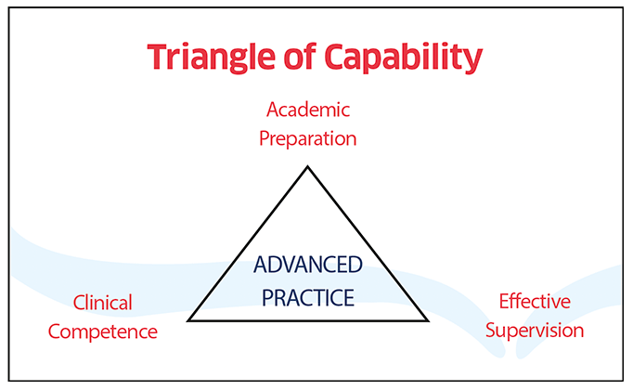
Figure 1 (CNOD, 2021)
“Reflective practice and clinical supervision are seen as approaches to enable nurses, midwives, and allied health professionals (NMAHP) to reflect on aspects or events within their practice; to examine what happened, what was good or bad about the experience, what else could have been done and what could be changed or improved in practice as a result of this learning” (NHS Education for Scotland, 2017). HCPC (2021) suggest a number of additional advantages to clinical supervision (figure 2), suggesting benefit to the individual, patient care and the employer.
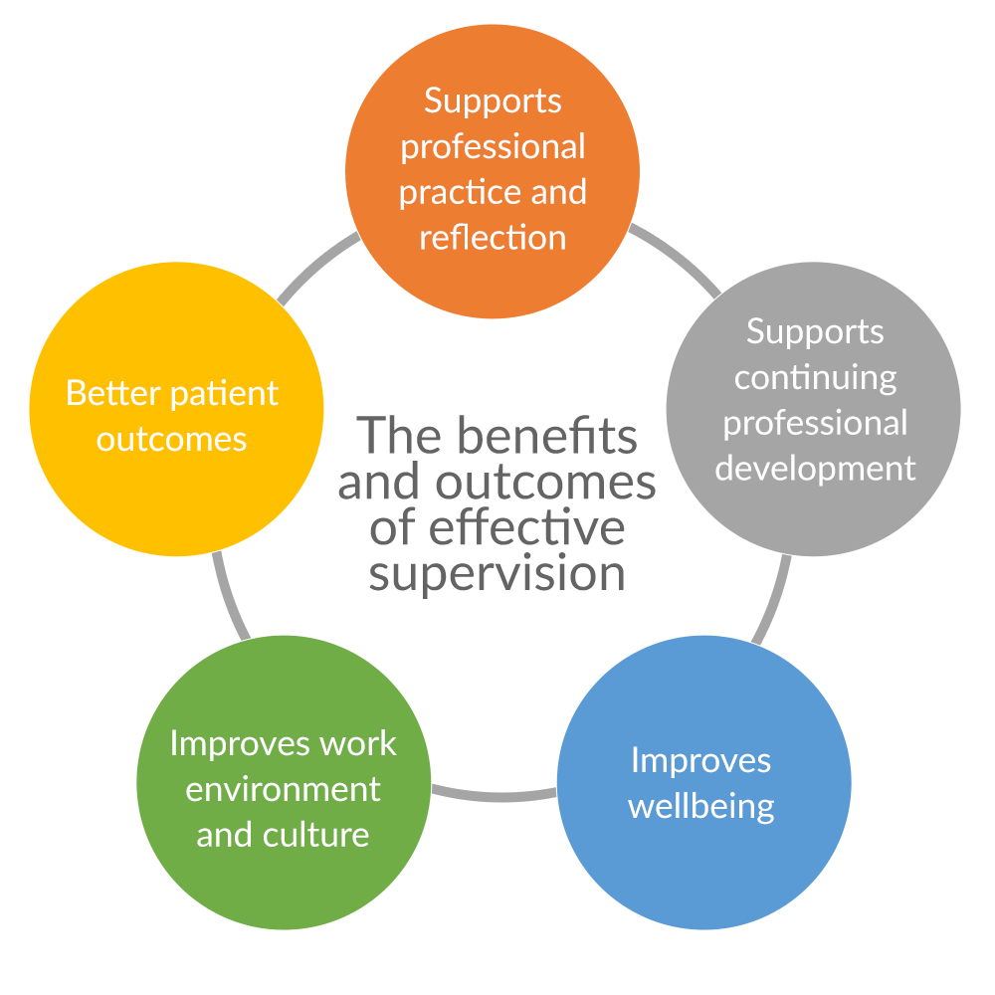
Figure 2 (HCPC, 2021)
Clinical supervision, supervision and practice supervision are all terms which have been used variably to describe the process, there is justification for using each term, though each also brings potential implications from past experience (NHS Education for Scotland, 2017). For this document, the term Clinical Supervision will be used, in line with the NHS Education for Scotland’s education package title. This is intended to make clear the difference between local management-based supervision and the clinically focused advanced practice supervision that this document aims to focus on. Clinical Supervision will be discussed throughout this document, encompassing the 3 functions of supervision – Normative, Formative and Restorative - depending on the needs of the individual and the type of supervision being offered (NES, 2021b). The functions of supervision are explained in Figure 4 (NES, 2021b).
The other elements of supervision – managerial and operational, are covered by the current arrangements for line managers within local stations. Figure 3 outlines the categories of supervision and demonstrates the crossover that takes place between them in the functions of supervision being offered (NES, 2021b).
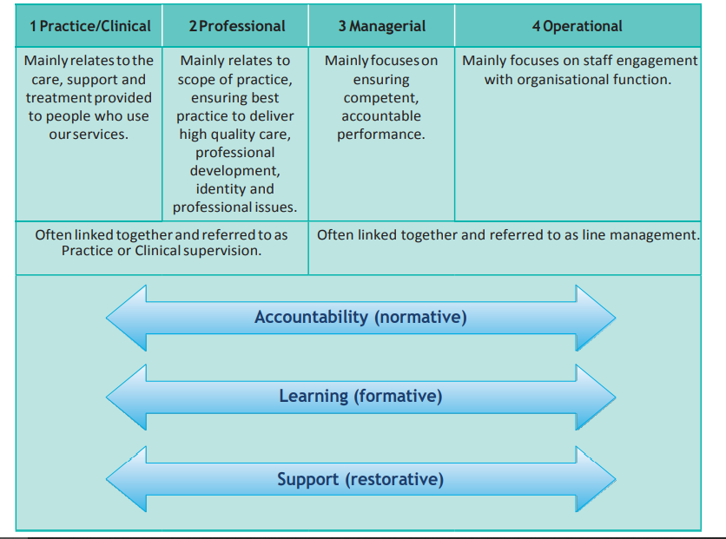
Figure 3 NES 2018

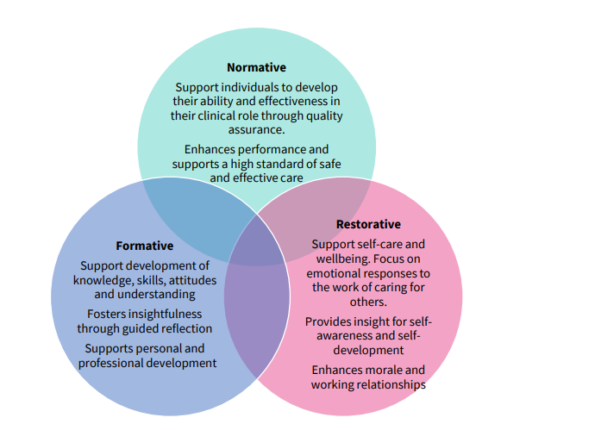
Figure 4 Proctor's functions of supervision NES (2021b)
SCIE (2017) advises that organisations should create a policy establishing the importance and commitment to clinical supervision, clarify the standards of delivery of clinical supervision and to plan for review and evaluation of clinical supervision. This document aims to set out the SAS guidance for the Clinical Supervision of advanced practitioners.

Clinical supervision policy writing process
This policy has been created using key principles of Clinical Supervision from the following – NES, 2018, NES 2021b, HCPC 2021. The Social Care Institute of Excellence (SCIE, 2017) document Effective Supervision in a variety of settings lists the areas to be considered by employers when writing their supervision policy, on completion of this document, the list was reviewed to ensure all areas had been considered appropriately.
The following principles of clinical supervision have been considered central to this policy -
- “the supportive element of supervision underpins all types of supervision SCIE, 2017)
- “The supervisee needs to feel emotionally ‘safe”’ to gain the most benefit from supervision (SCIE, 2017; NES, 2021b).
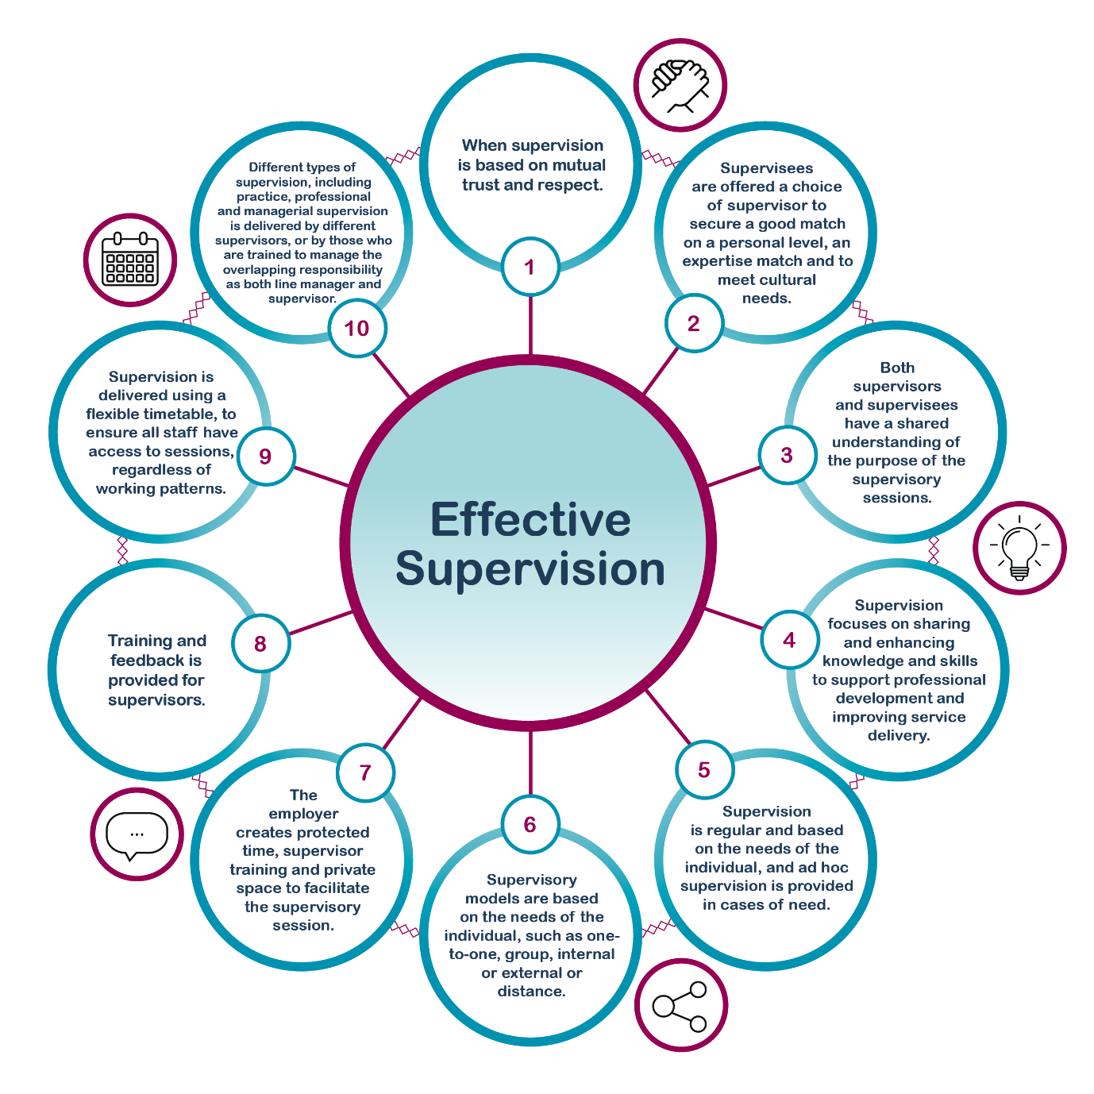
Figure 5 (HCPC, 2021)

The Clinical Supervisor
CNOD (2021) state “A supervisor’s skill set is one of the most important aspects of successful clinical supervision implementation.” They suggest that a local process for clinical supervisor selection, preparation and practice will promote a quality assured provision.
NES (2017) suggest several key attributes of effective clinical supervisors:
- “A high degree of emotional intelligence and self-awareness
- Professional autonomy
- Effective leadership skills
- Non-judgemental and empathetic approach
- Trustworthy
- Display professional integrity
- Committed to developing quality of care through staff development and experience”.
A competency tool for clinical supervisors is currently being developed by NES (CNOD, 2021). This may influence future requirements for clinical supervisors. While this has not yet been developed, there is some clarity on the knowledge, training and registration of clinical supervisors in the SAS approved Competency Framework for APs in Urgent and Primary care: “The Clinical Supervisor will be an experienced senior clinician who is doing or is able to do the same job the trainee APP/ANP is preparing for. This individual could be a suitably qualified and experienced APP/ANP or they may be another suitably qualified and experienced healthcare professional, most often a Consultant, General Practitioner, Specialist or registrar. They must be registered by their Registering Body (NMC, GMC, HCPC) and have no limitations on their practice. Preferably, they should hold a recognised qualification or education in supporting healthcare professionals in practice” (MacLeod, 2020). MacLeod (2020) also defines some tasks which the clinical supervisor would be expected to undertake “the clinical supervisor will be willing and able to share their professional knowledge whilst working in partnership with the trainee APP/ANP, and to guide and support them throughout the period of their particular learning with the intention of ensuring the well-being of patients/clients and the professional development of their learner” MacLeod, 2020. In the absence of a clinical supervisor competency framework, the remaining criteria for the clinical supervisor annual review document have been borrowed from this document as a starting point for the annual review documentation (see appendix 1).

CNOD (2021) advise that organisations should determine whether clinical supervisors should be nominated or volunteer to undertake the role. They also suggest that engaging a range of backgrounds promotes equality and diversity as well as improving learning opportunities. Within SAS’s advanced practitioner cohort at present, there are significant numbers of trainees when compared to qualified staff numbers. This document therefore suggests that, particularly as SAS sets up a Clinical Supervision structure, that all qualified APs are encouraged to consider whether they meet the requirements to act as a Clinical Supervisor. When the Clinical Supervision structure is established, all qualified APs will be asked on an annual basis to consider whether they can undertake a Clinical Supervision role, as part of the Clinical Appraisal process.
The Clinical Supervisor role allows the Advanced Practitioner to be involved at least 2 of the 4 pillars of Advanced Practice - Facilitating Learning and Leadership. Depending on the individual Supervisor and Supervisees, it may also allow for opportunities to develop the other 2 pillars – Clinical practice and Evidence, research and development.

Allocation of Clinical Supervisors and Supervisees
The Regional Leads allocate Supervisees to Clinical Supervisors. Clinical Supervisors are accountable to the Regional Leads. One of the HCPC Principles is the individual being able and encouraged to identify their own Clinical Supervisor (HCPC, 2021). As the supervision infrastructure is in the early stages of being developed, this is challenging to include in the policy. It is therefore anticipated that consideration for this will be made when the policy is reviewed, for its inclusion at a later date.
If a Clinical Supervisor cannot provide what is required for their Supervisee, e.g., they will be off on an extended period of leave, they will either put a plan in place for the supervisee for that period or agree with the Regional Lead to allocate an alternate clinical supervisor.
All APs will have a named Clinical Supervisor.

Setting up the Supervisee / Clinical Supervisor relationship
The clinical supervisee should complete the NES Clinical Supervision module, unit 1. Further information on clinical supervisor preparation is outlined in the clinical supervisor support and training section below.
A contract should be agreed between the clinical supervisor and the supervisee at the beginning of the relationship is important to set boundaries, develop trust and encourage shared responsibility (NMC, 2010; HCPC, 2021; NES, 2021b). Initial contract paperwork should be made clear by the organisation (SCIE, 2017). Appendix 4 outlines the SAS Clinical Supervision Contract paperwork, which has been adapted from the HCPC template. Further guidance on completion of this paperwork can be found through this link -supervision-agreement-template.pdf (hcpc-uk.org) .
A copy of this contract should be retained by the clinical supervisor and the supervisee, so that it can be referred to as required. There is no requirement to submit this paperwork to the Clinical Leads or to the individual’s training folder.

Frequency of clinical supervision sessions
There is a lack of evidence about the number of clinical supervision sessions that should be delivered (Pollock et al., 2017). In 2018, NES suggested 4 to 6 formal clinical supervision sessions would be appropriate, the approved SAS Competency Assessment Framework document (MacLeod, 2020) recommends a 6-8 weekly basis for clinical supervisor meetings. Alternatively, NES (2021b), suggest scheduled clinical supervision should be available every 4-6 weeks, acknowledging there will be times where greater support is needed, suggesting the following will impact on the frequency of supervision –
- Supervisee experience
- Nature / complexity of role
- Supervisee’s support needs.
Within the SAS Competency Assessment Framework document (MacLeod, 2020) there is also a recommendation for trainee AP supervisees to receive a combination of 1:1 meetings and time spent with suitably qualified assessors through work-based learning opportunities, overseen by the clinical supervisor. Therefore, it is anticipated that clinical supervision will be offered to meet the needs of the individual, with the frequency and timing of sessions agreed through the initial contract meeting and then reviewed on a regular basis.

Most sessions will last an hour, depending on circumstances and focus of the planned session (NES, 2018, NES 2021b). NES (2021b) also advise that sessions should largely be planned, this includes consideration for the appropriate learning environment, time and planned focus of the session.

Learning environment
Accessibility should be an important consideration to ensure engagement (NES, 2021b). NES (2021b) suggest offering online clinical supervision, offering flexibility in location and time and making processes such as booking clinical supervision sessions simple, are all ways to improve accessibility. The environment should provide a safe and conductive learning environment, regardless of the format and location (NES, 2021b).
The types or formats of clinical supervision, outlined by NES (2021b) are summarised in the table below:
Type | Description | Who can deliver (SAS requirement)
1:1 supervision | Individual supervision | Clinical Supervisors who have completed their annual checklist
Group supervision (suggested up to 6 participants) | Small group of supervisees facilitated by a supervisor – can have a fixed membership group (closed group) or a group of interchanging members (e.g. a drop-in group) | Clinical Supervisors who have completed their annual checklist and received additional training in facilitating small group-based learning.

As there are pros and cons to each format and some work better for individuals, or the particular focus of a session, NES (2021b) advise that offering varied options for the format of clinical supervision sessions will help staff to find the perfect blend.
Peer learning, reflective practice and informal learning should supplement, not replace, planned clinical supervision (NES, 2021b).
There is no definitive supervisor to supervisee ratio as there are several variables – time available, type of supervision, level of supervision (such as a trainee who needs more time), supervisor experience (NES, 2021b).
Clinical supervision should, where possible, be prioritised (NES, 2021b). Any sessions that are cancelled, should be re-scheduled as soon as practically possible.

Time commitments
Clinical Supervisors will negotiate time with their local managers as part of the annual Clinical Appraisal process. During this discussion, they will agree how many supervisees they are able to support. It is anticipated that new clinical supervisors will undertake supervision of one or two colleagues, while being supported and consolidating their own clinical supervision journey. It is expected that more experienced clinical supervisors can discuss the local need, time they can be freed up for, level of support that individuals are likely to need and their current commitments to come up with a reasonable plan for the number of supervisees who can be allocated to them.
It is anticipated that supervisees will make use of the 1.5 hours per week CPD time to engage with the Clinical Supervision process. Clinical Supervisors will negotiate time with their local managers to undertake the role, discussions can also be supported by the Regional Clinical Leads if required. Clinical Supervisors will need to have flexibility to move shifts to accommodate supervision – current SAS requirements for UPC APs mean that Remote Consultation and Primary Care / OOH Placement hours should not be changed.
Clinical supervisors should also be offered clinical supervision. This will initially take place in the form of a 6-weekly meeting with a member of the AP Leadership team. This will be an opportunity to identify the supervisor’s learning needs, as well as to discuss any clinical supervisee issues that have arisen.

Session format (regardless of 1:1, group, remote, face-to-face plans):
Session is planned – location, time and content. This is communicated to the supervisee.
At the start of the session – both the supervisor and the supervisee arrive prepared.
Agree items for discussion
Review past supervision meeting, including decisions and outcomes
Evaluate the session
Recording the session.

Documentation
The supervisor should keep records of clinical supervision offered to the supervisee, for monitoring purposes.
The Competency Assessment Framework document (MacLeod, 2020) states the Clinical Supervisor should ensure completion of relevant paperwork. It is important for the supervisee to complete the paperwork (appendix 2) to ensure a shared understanding of the supervision received. The supervisor and supervisee will agree a process for paperwork completion as part of their initial supervision contract (appendix 4).

Additional guidance on completing the clinical supervision session record can be found through the following HCPC link - supervision-recording-template.pdf (hcpc-uk.org).

In the case of restorative supervision “the supervisee is responsible for keeping any notes required and can discuss sharing of these with the supervisor if appropriate” (NES 2021b).

Confidentiality
One of the principles of supervision is that it is a confidential process, between the supervisor and the supervisee (NES, 2021b). The supervision record (appendix 2) is an organisational document. For ease of storage, it is suggested that an electronic copy of the record is held in the supervisee’s training folder. The supervisee’s personal notes from restorative supervision are not organisational documents and can be held by the individual only, unless otherwise agreed.
If there is an intention to disclose any confidential information, all parties must be informed (NES, 2021b). All paperwork will be managed and stored in accordance with the Scottish Ambulance Service’s Information Governance Policy (2018).
The principles of confidentiality should be discussed at the supervision contract discussion (NES, 2021b), including examples of where confidential information might need to be shared, these are outlined in the NES (2021b) Position Statement.

Evaluation and feedback
There should be consideration for regular evaluation of clinical supervision, including provision and uptake, quality of the experience, supervisor competence, including appropriate preparation of the supervisor (NES, 2021b, SCIE, 2017). Appendix 3 contains annual feedback questions to be presented to key stakeholders by the supervisor on an annual basis. Supervisors are welcome to add to these for their own learning / to get feedback on areas they have been working on, they are also welcomed to present these in their preferred format to the stakeholders involved.
In preparation for their annual clinical appraisal, clinical supervisors should request feedback from their supervisees. At the clinical appraisal, clinical supervisors will also be asked to provide feedback on their experience. Although some of the feedback is not about the individual clinical supervisor, this will provide an annual check-in point with the supervisor’s Clinical Lead. At this stage, patterns in feedback can be noted and this policy reviewed if necessary. In addition, this will also allow any supervisor learning needs to be included in their personal development plan.

Clinical Supervisor support and training
Clinical Supervisors must be appropriately prepared for the role (NES, 2021b). There are 2 relevant modules from NES, NES Clinical Supervision and NES Practice supervisors and practice assessors’ learning resource. These have been included as requirements for staff to undertake a Clinical Supervision role. The benefits and need for both modules will be evaluated at the next clinical supervision policy review, after feedback from clinical supervisors who have gone through the process.
Consideration must also be made for continued development of clinical supervision proficiency (NES, 2021b). Feedback, annual review of the individual’s ability to undertake the clinical supervision role and annual clinical appraisal processes will make consideration for this.
Facilitating group clinical supervision is a skill that is expected to be undertaken by the experienced clinical supervisor. At the annual appraisal meeting, action plans can be implemented to support, mentor and train clinical supervisors to develop their clinical supervision for a group setting if required.

Supervision issues or concerns
Formal annual feedback and evaluation will take place. The process of Clinical Supervision should aim to encourage a shared approach between Supervisor and Supervisee, where feedback, open discussion of issues and joint problem solving is encouraged (SCIE, 2017). It should also be acknowledged that individuals can be mismatched, and unresolved issues can arise (NES, 2021b). In this instance, the clinical supervisor and the supervisee are both able to contact the Regional Clinical Lead, who can negotiate the relationship and identify an alternative clinical supervisor if required.
The clinical supervisor will have regular meetings with the Regional Lead and have the opportunity to discuss concerns or highlight any supervisee engagement issues at these meetings.

Clinical Supervision provided by other health boards
In rural locations, or in certain individual circumstances, it will potentially be more appropriate for a clinical supervisor from a local health board to be identified. In this case, the clinical supervision governance will be provided by the local health board’s policy and infrastructure. Placements in hospital, primary care or out of hours settings for SAS staff have a memorandum of understanding in place, including measures to monitor the provision of clinical supervision.

References
CNOD, 2017. Transforming Nursing, Midwifery and Health Professions’ (NMaHP) Roles: pushing the boundaries to meet health and social care needs in Scotland. CNOD. [Online] Available at: Paper 2: Advanced nursing practice - Transforming nursing, midwifery and health professions roles: advance nursing practice - gov.scot (www.gov.scot) [Accessed 25 March 2022].
CNOD, 2021. Transforming Nursing, Midwifery and Health Professions’ Roles: pushing the boundaries to meet health and social care needs in Scotland. [Online] Available at: Supporting documents - Transforming Nursing, Midwifery And Health Profession (NMaHP) roles: review of Clinical Nurse Specialist and Nurse Practitioner roles within Scotland - gov.scot (www.gov.scot) [Accessed 24 March 2022].
HCPC, 2021. The benefits and outcomes of effective supervision. [Online] Available at: The benefits and outcomes of effective supervision | (hcpc-uk.org) [Accessed 25 March 2022].
HCPC, 2021b. Key characteristics of effective supervision. [Online] Available at: Key characteristics of effective supervision | (hcpc-uk.org) [Accessed 30 March 2022].
MacLeod, G., 2020. Advanced Paramedic / Nurse Practitioner Urgent and Primary Care: Competency Assessment Framework. Scottish Ambulance Service, Advanced Practice Strategic Group.
NES, 2018. Scotland’s Position Statement on Supervision for Allied Health Professions. [Online] Available at: 179c9639-aea3-4f02-8f78-38af8cd4bf2a_AHP Supervision Statement Sept 18.pdf (windows.net) [Accessed 1 April 2022].
NHS Education for Scotland, 2021. Clinical supervision: nursing and midwifery workforce. Position statement. [Online] Available at: NES Position Statement - Clinical Supervision: Nursing & Midwifery Workforce (Scotland) | Turas | Learn (nhs.scot) [Accessed 28 March 2022].
NHS Education for Scotland, 2021b. Restorative clinical supervision for nurses and midwives implementation guidance for strategic leads and managers. [Online] Available at: Restorative supervision guidance for strategic leads (nursing & midwifery workforce) | Turas | Learn (nhs.scot) [Accessed 25 March 2022].
NMC, 2010. Standards for competence for registered nurses. [Online] Available at: nmc-standards-for-competence-for-registered-nurses.pdf [Accessed 28 March 2022].
Pollock, A., Campbell, P., Deery, R., Fleming, M., Rankin, J., Sloan, G. & Cheyne, H. (2017) A systematic review of evidence relating to clinical supervision for nurses, midwives and allied health professionals. Journal of Advanced Nursing, 83 (8), pp. 1825-1837. https://doi.org/10.1111/jan.13253
Social Care Institute of Excellence, (SCIE, updated 2017), Effective supervision in a variety of settings. SCIE Guide 50. available at: http://www.scie.org.uk/publications/guides/guide50/contextforeffectivesupervision/index.asp

Appendix 1 - Clinical Supervisor Criteria
This document will initially be a stand-alone document, which should be completed and sent to the UPC shared email address, for staff to be added to the register of clinical supervisors.
When the Clinical Appraisal process is complete and up and running, this is intended to form part of that annual process and inclusion on the register of clinical supervisors will be automatic for staff who continue to meet the criteria.

SAS criteria from Competency Framework | Evidence | Checklist in preparation for Clinical Lead meeting
They must be registered by their Registering Body (NMC, GMC, HCPC) and have no limitations on their practice. | Qualified AP, medical staff working within SAS. | ☐
The Clinical Supervisor will be an experienced senior clinician who is doing or is able to do the same job the trainee APP/ANP is preparing fo.  This individual could be a suitably qualified and experienced APP/ANP or they may be another suitably qualified and experienced healthcare professional, most often a Consultant, General Practitioner, Specialist or registrar. | Qualified AP, medical staff working within SAS. | ☐
Competent and confident | Up to date clinical appraisal | ☐
Preferably, they should hold a recognised qualification or education in supporting healthcare professionals in practice | Completion of NES Clinical Supervision – units 1 to 4 Clinical supervision | Turas | Learn (nhs.scot)  Completion of Practice supervisors and practice assessors’ learning resource NES – units 1 to 6 Practice supervisors and practice assessors’ learning resource | Turas | Learn (nhs.scot) | ☐  ☐
The clinical supervisor will be willing and able to share their professional knowledge whilst working in partnership with the trainee APP/ANP, and to guide and support them throughout the period of their particular learning with the intention of ensuring the well-being of patients/clients and the professional development of their learner | New Clinical Supervisors – testimonial from 2 colleagues about the suitability for the role based on mentoring and support received  Continuing Clinical Supervisors – feedback gathered from supervisees  Evidence to be presented and discussed at meeting to determine suitability for role with consideration for the key attributes of effective clinical supervisors, noted above.  After discussion, anyone who is not deemed suitable for the role at present should have an action plan put in place to help support their development into the role. | ☐  OR  ☐

Role and expectations have been discussed with ASM / a suitable operational manager –
Agreed the staff member is suitable to undertake the role | ☐
Agreed ability to release to provide clinical supervision for named APs | ☐
Agreed terms of release and facilitation of clinical supervision | ☐  Please provide details:
ASM / Operational Manager Signature
Date of discussion

Suitable to undertake the Clinical Supervision role for the next 12 months:
Date of discussion with Clinical Lead
All of the above criteria have been met
Deemed suitable to provide group clinical supervision (experience, confidence, support already received will all impact on this)
New Clinical Supervisors - Action plan for development into the clinical supervision role has been agreed  Experienced Clinical Supervisors - Action plan for development in response to feedback has been agreed | ☐  OR  ☐

Appendix 2 Clinical Supervision Meeting Summary paperwork
Adapted from HCPC (2021).
Summary of Clinical Supervisor meeting
Trainee Advanced Practitioner – Urgent and Primary Care
Scottish Ambulance Service

Date and start / finish times
Location

Trainee AP’s details
Name
NMC/HCPC number
NHS email address
Payroll number

Clinical Supervisor
Name
Position
HCPC/NMC/GMC number
NHS email address

Aims or purpose of today’s clinical supervision session:

What have you achieved since your last clinical supervision?

What challenges have you faced since your last supervision?

What future learning objectives have you identified and what do you hope to achieve before your next supervision?

Feedback from clinical supervisor:

What actions have been agreed?

When will your next clinical supervision session be?

Agreed as a summary of meeting:
Clinical Supervisor | ☐ Date -
Trainee Advanced Practitioner | ☐ Date -

Additional information on completion available through this link - supervision-recording-template.pdf (hcpc-uk.org)

Appendix 3 – feedback for clinical supervision
Questions to be formulated based on the HCPC principles and SCIE areas that supervision should encourage –
HCPC PrinciplesBoth supervisors and supervisees have a shared understanding of the purpose of the supervisory sessions
Supervision focuses on sharing and enhancing knowledge and skills so support professional development and improving service delivery
Supervision is regular and based on the needs of the individual and ad hoc supervision is provided in cases of need.
Different types of supervision including practice, professional and managerial supervision is delivered by different supervisors, or by those who are trained to manage the overlapping responsibility as both line manager and supervisor.
Supervision is based on mutual trust and respect
Supervisees are offered a choice of supervisor to secure a good match on a personal level, an expertise match and to meet cultural needs
Training and feedback is provided for supervisors
Supervision is delivered using a flexible timetable to ensure all staff have access to sessions regardless of working patterns
The employer creates protected time, supervisor training and private space to facilitate the supervisory sessions
Supervisor models are based on the needs of the individual, such as one to one, group, internal or external or distance
SCIE criteria (2017) – • Is the quality of supervisory relationships evaluated in relation to how successfully they facilitate a culture of openness, where the quality of the supervisee’s practice can be accurately assessed?
- Does the organisation promote the importance of emotionally intelligent practice, including empathy and emotional attunement, both within supervision and with people who use services?
- Is supervision based on a balanced use of authority (neither collusive nor punitive), mirroring practice, which is underpinned by a partnership approach and the principles of anti-oppressive practice?
- Does supervision practice integrate with broader opportunities for practice learning and development such as mentoring, shadowing and co-working?
- Do supervision records demonstrate clear plans both for the development of the supervisee and for work with people who use services? Are these plans based on both reflection and analysis of the issues?
- Does the policy promote a supervisory relationship where supervisees are able to explore confusions, anxieties and dilemmas in order that they develop a sense of security in their role?

Appendix 4 SAS Clinical Supervision Contract Agreement
Adapted from HCPC (2021)
Supervisee
Clinical Supervisor
Date of initial agreement

Supervisee has completed the NES Clinical Supervision module Unit 1 | ☐
Clinical supervisor has completed the NES Clinical Supervision module Units 1-4 | ☐

What’s the aim or purpose of your supervision?

What structure will your supervision take?

How frequent will your supervision be?

Where will the supervision take place?

Who will be supervising you?

How will the sessions be documented?

How will feedback be provided and what are the terms of confidentiality?

What are the confidentiality terms?

